UC Riverside Film Presentation:

FOOD, INC.

UCR Sustainable Foods Discussion


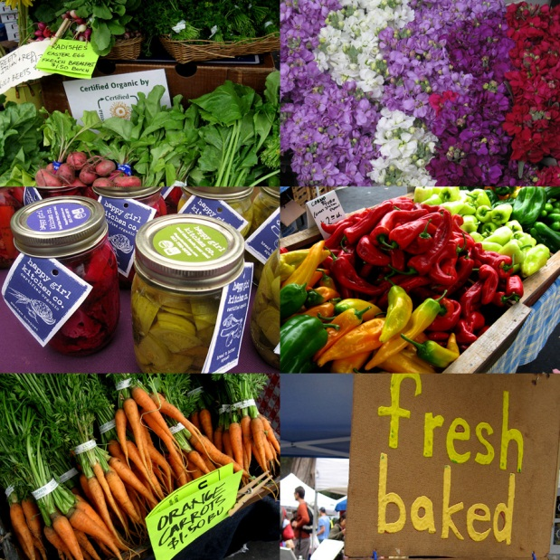
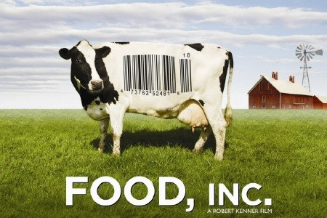

Learn about Food Justice
Get Involved
Voice your Opinion

Join Us, FREE food:

UNLH 1000
February 24th, 2011
5-7pm
Make a Difference at UC Riverside!

Presented by: Sustainable UCR
Co-Sponsored by: ASUCR and UCR Office of Sustainability

Contacts: john.cook@ucr.edu and etizc001@ucr.edu

